***Understanding EIBP***

**EIBP – Expedited Internet By-pass Protocol**

**Background:**

OSPF (Open Shortest path First) protocol uses a Link state database to publish the link state information to all the routers in the network. Once all the routers populate the link state database, it then computes the Dijkstra tree (algorithm) to populate the routing table with the shortest path to reach other routers in the network. To scale, OSPF requires large networks be segmented into areas, to limit the flooding and tree construction to an area. The use of only technical metrics to construct the Dijkstra tree and areas to limit flooding makes OSPF unsuitable for inter-AS routing.

BGP (Border Gateway Protocol) uses a more scalable approach called path vector approach to route discovery. When we have 2 or more autonomous systems(AS) and to connect them we use BGP routers. BGP sends discovery messages to determine an AS path to distant networks. At the border routers connecting two AS, OSPF is used to populate routing tables for intra-AS operations for communicating between networks internal to the AS.

**EIBP:**

To address these performance challenges in EIBP we have a clean slate approach which is the Expedited Internet By- pass protocol (EIBP). EIBP works in parallel with IP and has no dependency on layer 3 protocols. Networks are designed around a modular architecture which consists of Core Routers, Distribution Routers, and Access Routers in three different tiers. This architecture is scalable and easy to troubleshoot. EIBP exploits the structure in network architectures to auto-assign addresses to routers in the network. EIBP can also use virtual structures superimposed on the physical network structure.

**How Routing a Packet works in EIBP?**

EIBP captures the relative position of a router in the network structure into a routable address and uses this information to route packets. EIBP thus introduces a new auto-addressing scheme that does not require route discovery. Routers running EIBP acquire multiple routable addresses to provide immediate fallback paths in the event of a path failure. EIBP does not use IP addresses. For backward compatibility with IP, it operates at layer 2.5 in parallel with IP at layer 3. EIBP forwards traffic between end IP systems and networks by encapsulating them in EIBP headers, which use the EIBP, assigned routable addresses.

**Explanation:**

Please refer to the attached Fig 1.

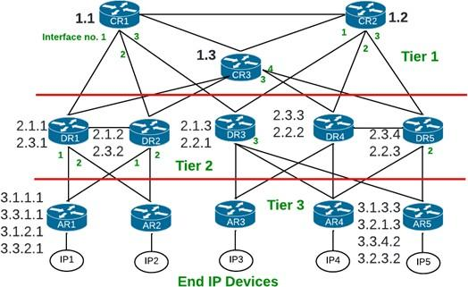

**Fig.1**

As shown in the Fig. 1:

* CR1, CR2, CR3 are the Core Routers (CR) which form the backbone for the architecture. They are available in Tier 1.
* AR1, AR2, AR3, AR4, AR5 are the access routers (AR) that are connected to the access networks and end users. They are available in Tier 2.
* DR1, DR2, DR3, DR4, DR5 are the distribution routers (DR) that are connected to the access router/networks and to the core routers. They are available in Tier 3.

**How are labels auto assigned in EIBP?**

EIBP auto assigns routable addresses to all the routers which are unique and reusable. Below are the steps involved:

* Core routers are configured with a unique ID consisting of the tier value followed by a unique integer value. CR1 is configured with an address 1.1, CR2 with address 1.2 and respectively. These 1.1, 1.2, and 1.3 labels are assigned to the CR’s manually in the command file. 1 is the tier value and .1, .2, .3 are the unique integer values to CR’s in an order. So, the 1st step is Core routers announce their unique addresses on their active interfaces.
* The distribution routers send a request to the CR’s for an Id. This ID specifies the DR tier value as well which is tier 2. After receiving the request, Tier 1 routers create an ID by appending their unique integer value and the port number/interface number on which the request arrived to the tier value of the distribution router.

Ex: Let’s give the label to DR1 that is assigned by the CR1 router.

CR1 label is 1.1 and the interface number is 1 that is connected on DR1.

So DR1 gets a label 2.1.1 from CR1.

2 🡪 Tier value of DR1

.1 🡪 Unique integer value/ID of CR1 (after extracting the tier value)

.1 🡪 Is the Interface number on which both CR1 and DR1 are connected.

We can get these interface numbers/port numbers from MobaXterm after we reserve the resources in the GENI portal.

* The access routers on startup send a request for an address on their active interfaces and they receive labels from the distribution routers DR’s. Thus, AR1 receives address 3.1.1.1 and 3.3.1.1 from DR1 and 3.1.2.1 and 3.3.2.1 from DR2 on its interface ‘1’ respectively.

Ex: Let’s give the labels to AR1 that is assigned by the DR1 router.

DR1 has 2 labels because it is connected to CR1 and CR3. So, AR1 also receives 2 labels DR1 which is again appended by the AR1 tier value which is 3 followed by the unique ID of DR1 and the port number on which DR1 and AR1 are connected. So, the labels are 3.1.1.1 and 3.3.1.1.

3.1.1.1 Explained:

3 🡪 Tier value of AR1

.1.1 🡪 Unique ID of DR1 (after extracting the tier value)

.1 🡪 Is the Interface number on which both DR1 and AR1 are connected.

**How labeling works to forward the packet in EIBP?**

So, the addresses received by the DRs and ARs can identify a path to reach a core router. Similarly, given an access router address, the core and distribution routers know the path to forward a packet to the destination IP address (i.e., the access router to which the destination IP address is connected to). Besides the parent-child information in-built in the EIBP addresses, routers also record their neighbor’s EIBP addresses, which is advertised in the hello messages.

The assignment of the routable addresses in EIBP sets up the routes to forward packets between a pair of access routers that are part of one autonomous system or between two different autonomous systems. EIBP achieved this without flooding route discovery messages. To route a packet across access routers, EIBP routers compare the destination router’s EIBP address with their addresses and the addresses in their neighbor tables to find a common upstream or a closest neighbor router to forward the packet towards the destination.

**Another example of a small topology to understand the labeling concept:**

This is an Intra-AS topology.

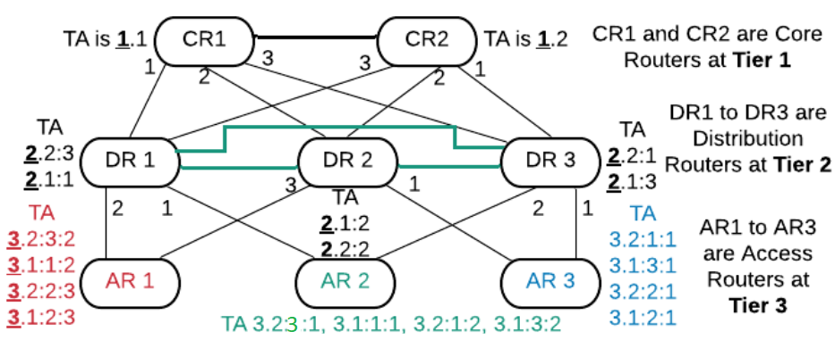

**Fig. 2**

**EIBP in the Data Plane:**

Access routers record the network addresses of the IP end devices or networks connected on their interfaces. Also, once the AR’s receive their labels from all their parent nodes (any connected nodes), they are mapped to the IP subnet address to the core routers. Thus, core routers have knowledge of the EIBP addresses to forward IP packets destined to an IP end device or network. The core routers thus provide EIBP address to IP subnet address mapping services to queries from the access routers.

When an IP packet arrives from an end IP device/network, the access router will check if it has the destination IP address in its local EIBP address to IP address map. If not, it sends a query to the core router. The core router responds by providing all the EIBP addresses of the access router connecting to the destination IP end device or network.

The access router then builds an EIBP header, with the source access routers and the destination access router’s EIBP addresses and encapsulates the IP packet. Intermediate forwarding EIBP routers compare the destination EIBP address with their EIBP addresses and addresses in their neighbor table and forward the encapsulated IP packet towards the destination access router. The table entries to compare are limited and a string comparison will provide the direction (interface) to forward the packet to. When the encapsulated IP packet arrives at the destination access router, this router recognizes that it is the destination and it will remove the EIBP header and deliver the IP packet to the destination end device/network.

Encapsulation is only done by the end nodes.

**Hello Messages Information:**

Hello messages are used to advertise a router’s EIBP addresses.

Hello message structure:



**Fast Failure Recovery:**

By increasing the frequency of hello messages, we can detect neighbor failures faster and stabilize the tables faster. EIBP announces a neighbor failure on missing a single hello message and falls back to the next address. It sends a prune message to delete any addresses derived from the failed EIBP address. We avoid the toggling interface problem by accepting a neighbor on a failed interface after receiving three consecutive hello messages. EIBP fast failure recovery is inherent to the protocol.

**How routing works in Inter-AS topology which has 2 or more Autonomous Systems (AS)?**

In order to communicate between the AS’s, we need the border routers to connect the AS’s. Please refer to Fig.3. The Labeling concept remains the same as Intra-AS.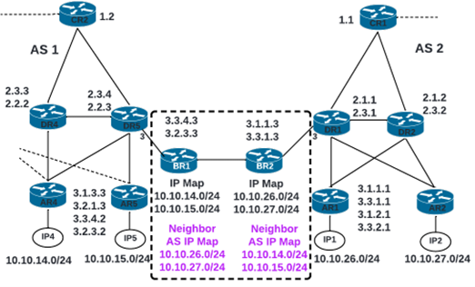

**Fig. 3**

**BR Nodes:**

BR1 receives the network IP addresses of AS1 from the core router and stores this information in a local IP map. Similarly, BR2 stores the local IP map from AS2. The BR’s exchange their local network IP addresses and store them in a Neighbor AS IP map. This is the route set up in the border routers required for inter-AS routing between two AS.

**Inter-AS IP packet routing with EIBP:**

When an IP device IP4 @ 10.10.14.0/24 network in AS1 sends an IP packet to IP device IP1 available 10.10.26.0/24 in AS2. The IP packet header contains source IP address = 10.10.14.1 and destination IP address = 10.10.26.1. AR4 at AS1 checks the destination IP address in its local IP to EIBP address map and finds no match. Because it didn’t find a match, it then sends a resolution query to a core router. CR2, a tier 1 router, checks his IP to EIBP address map and finds no entry for network 10.10.26.0/24. It then forwards the query to BR1. BR1 returns its EIBP address mapped to the destination IP address 10.10.26.0/14, recorded in its neighbor AS IP table. CR2 forwards the response to AR4. AR4 caches the resolved IP address to EIBP address map. It then creates an EIBP header with one of its EIBP addresses as source, and BR1’s EIBP address as destination. The forwarding algorithm in EIBP will forward this encapsulated IP packet to BR1. When it reaches BR1, this router will de-encapsulate the IP packet and because the destination IP address is from a neighbor AS table, it will forward the IP packet to BR2. BR2, will check the destination IP address and send a resolution request to a tier 1 router for the AR’s EIBP address that connects to the destination IP address. The tier 1 router will return EIBP addresses of AR1 in AS2. BR2 will re-encapsulate the IP packet with its EIBP address as source and EIBP address of AR1 in AS2 as destination address and forward the IP packet towards AR1 in AS2. AR1 will remove the EIBP header and deliver the IP packet to destination IP device IP1 in AS2.